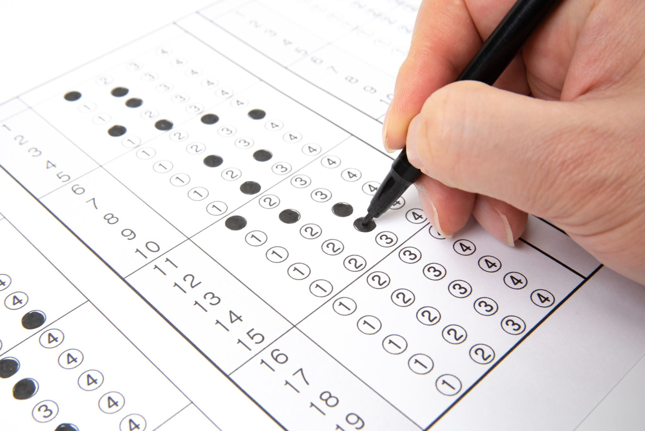

Conditional statement:

1. Print First 10 natural numbers using while loop
2. [Calculate the sum of all numbers from 1 to a given number](https://pynative.com/python-if-else-and-for-loop-exercise-with-solutions/#h-exercise-3-calculate-the-sum-of-all-numbers-from-1-to-a-given-number)
3. [Write a program to print multiplication table of a given number](https://pynative.com/python-if-else-and-for-loop-exercise-with-solutions/#h-exercise-4-write-a-program-to-print-multiplication-table-of-a-given-number)
4. [Display numbers from a list using loop](https://pynative.com/python-if-else-and-for-loop-exercise-with-solutions/#h-exercise-5-display-numbers-from-a-list-using-loop)
5. [Count the total number of digits in a number](https://pynative.com/python-if-else-and-for-loop-exercise-with-solutions/#h-exercise-6-count-the-total-number-of-digits-in-a-number)
6. [Print list in reverse order using a loop](https://pynative.com/python-if-else-and-for-loop-exercise-with-solutions/#h-exercise-8-print-list-in-reverse-order-using-a-loop)
7. [numbers from -10 to -1 using for loopDisplay](https://pynative.com/python-if-else-and-for-loop-exercise-with-solutions/#h-exercise-9-display-numbers-from-10-to-1-using-for-loop)
8. [Use else block to display a message “Done” after successful execution of for loop](https://pynative.com/python-if-else-and-for-loop-exercise-with-solutions/#h-exercise-10-use-else-block-to-display-a-message-done-after-successful-execution-of-for-loop)
9. [Write a program to display all prime numbers within a range](https://pynative.com/python-if-else-and-for-loop-exercise-with-solutions/#h-exercise-11-write-a-program-to-display-all-prime-numbers-within-a-range)
10. [Display Fibonacci series up to 10 terms](https://pynative.com/python-if-else-and-for-loop-exercise-with-solutions/#h-exercise-12-display-fibonacci-series-up-to-10-terms)
11. [Find the factorial of a given number](https://pynative.com/python-if-else-and-for-loop-exercise-with-solutions/#h-exercise-13-find-the-factorial-of-a-given-number)
12. [Reverse a given integer number](https://pynative.com/python-if-else-and-for-loop-exercise-with-solutions/#h-exercise-14-reverse-a-given-integer-number)
13. [Find the sum of the series upto n terms](https://pynative.com/python-if-else-and-for-loop-exercise-with-solutions/#h-exercise-17-find-the-sum-of-the-series-upto-n-terms)
14. [Calculate the cube of all numbers from 1 to a given number](https://pynative.com/python-if-else-and-for-loop-exercise-with-solutions/#h-exercise-16-calculate-the-cube-of-all-numbers-from-1-to-a-given-number)
15. [Use a loop to display elements from a given list present at odd index positions](https://pynative.com/python-if-else-and-for-loop-exercise-with-solutions/#h-exercise-15-use-a-loop-to-display-elements-from-a-given-list-present-at-odd-index-positions)
16. Name the keyword which helps in writing code involves condition.
17. Write the syntax of simple if statement.
18. Is there any limit of statement that can appear under an if block.
19. Write a program to check whether a person is eligible for voting or not. (accept age from user)
20. Write a program to check whether a number entered by user is even or odd.
21. a program Write to check whether a number is divisible by 7 or not.
22. Write a program to display "Hello" if a number entered by user is a multiple of five ,

otherwise print "Bye".

1. Write a program to calculate the electricity bill (accept number of unit from user) according to the following criteria :

Unit Price

First 100 units no charge

Next 100 units Rs 5 per unit

After 200 units Rs 10 per unit

(For example if input unit is 350 than total bill amount is Rs2000)

1. Write a program to display the last digit of a number.

(hint : any number % 10 will return the last digit)

1. Write a program to check whether the last digit of a number( entered by user ) is

divisible by 3 or not.

1. Write a program to accept percentage from the user and display the grade according to the following criteria:

Marks Grade

> 90 A

> 80 and <= 90 B

>= 60 and <= 80 C

below 60 D

1. Write a program to accept the cost price of a bike and display the road tax to be paid according to the following criteria :

Cost price (in Rs) Tax

> 100000 15 %

> 50000 and <= 100000 10%

<= 50000 5%

1. program to check whether an years is leap year Write a or not.
2. Write a program to accept a number from 1 to 7 and display the name of the day like 1 for Sunday , 2 for Monday and so on.
3. Write a program to accept a number from 1 to 12 and display name of the month and days in that month like 1 for January and number of days 31 and so on
4. What do you mean by statement?
5. Write the logical expression for the following:

A is greater than B and C is greater than D

1. Accept any city from the user and display monument of that city.

City Monument

Delhi Red Fort

Agra Taj Mahal

Jaipur Jal Mahal

1. Write the output of the following if a = 9

if (a > 5 and a <=10):

print("Hello")

else:

print("Bye")

1. Write a program to check whether a number entered is three digit number or not.
2. Write a program to check whether a person is eligible for voting or not.(voting age >=18)
3. Write a program to check whether a person is senior citizen or not.
4. Write a program to find the lowest number out of two numbers excepted from user.
5. Write a program to find the largest number out of two numbers excepted from user.
6. Write a program to check whether a number (accepted from user) is positive or negative.
7. Write a program to check whether a number is even or odd.
8. Write a program to whether a number (accepted from user) is divisible by 2 and 3 both.
9. Write a program to find the largest number out of three numbers excepted from user.
10. Accept the temperature in degree Celsius of water and check whether it is boiling or not (boiling point of water in 100 oC.
11. the age of 4 people and display the youngest one and oldest one? Accept
12. Accept the following from the user and calculate the percentage of class attended:

a. Total number of working days

b. Total number of days for absent

After calculating percentage show that, If the percentage is less than 75, than student will not be able to sit in exam.

1. Accept three sides of a triangle and check whether it is an equilateral, isosceles or scalene triangle.

Note :

An equilateral triangle is a triangle in which all three sides are equal.

A scalene triangle is a triangle that has three unequal sides.

An isosceles triangle is a triangle with (at least) two equal sides.